Walmart Sales Intelligence
Eight statistical experiments and a business-impact layer over 421,570 store-department-week sales records
Live dashboard https://jeet-1236.github.io/walmart-sales-intelligence/
Source and code https://github.com/jeet-1236/walmart-sales-intelligence
Both are public. The dashboard opens in any browser with no sign-in and nothing to install; the repository holds the analysis pipeline, the computed tables and this document.
Dataset | Walmart Store Sales Forecasting (train, stores, features)
Grain | one row per store, department and week
Records | 421,570
Stores / departments | 45 stores, 81 departments
Period | 5 February 2010 to 26 October 2012 (143 weeks)
Total revenue | $6.74B
Tools | Python (pandas, NumPy, SciPy, scikit-learn), D3, Streamlit

Contents
1. Summary
2. The dataset and how it was built
3. Exploratory data analysis
4. The eight experiments
5. Business impact
6. Limitations
7. Reproducing this work
A. Appendix: full column profile

1. Summary
This chain turned over $6.74B across 143 weeks, 45 stores and 81 departments. Almost none of that movement is the economy. It is the calendar and the store itself: a regression on temperature, fuel price, CPI and unemployment explains 0.17% of the variance in weekly sales, while floor space alone carries most of what can be explained.

Headline figures
Measure | Value | Note
Total revenue | $6.74B | 143 weeks, all stores
Average week, chain-wide | $47.1M
Revenue per square foot | $1,149 | over the whole window
Largest week | $80.9M | week ending 24 Dec 2010
Quietest week | $39.6M | week ending 28 Jan 2011
Forecast error (MAPE) | 1.81% | 13 held-out weeks; seasonal-naive benchmark 2.04%
Productivity headroom | $1.69B | 25% of revenue; a ceiling, not a target

What the analysis found
- The holiday flag points at the wrong weeks. It marks the week ending 31 December, which is the dead week after Christmas and runs about 29% below its December baseline. The real annual peak, week 51, carries no flag at all, and three of the five biggest weeks on record are labelled normal.
- Small-format stores are the most productive floor space. Type C earns about $1,667 per square foot against Type A's $1,111, which holds at median-store level too. Type A is 4.4 times larger and takes 64% of revenue, so size and productivity rank in opposite directions.
- Markdown's apparent effect is mostly store-size confounding. Across records the deepest markdown quintile averages 110% above the lightest. Removing each store-department's own mean leaves a slope of about $0.015 of sales per markdown dollar, explaining roughly 0.1% of variance.
- Revenue is concentrated. 29 of 81 departments produce 80% of revenue, and the top ten stores carry 39% of it.
- The weekly number is highly forecastable. A trend-times-seasonality model reaches 1.81% MAPE on 13 weeks it never saw, against 2.04% for a seasonal-naive benchmark. The underlying trend is close to flat, so nearly all movement is calendar rather than growth.
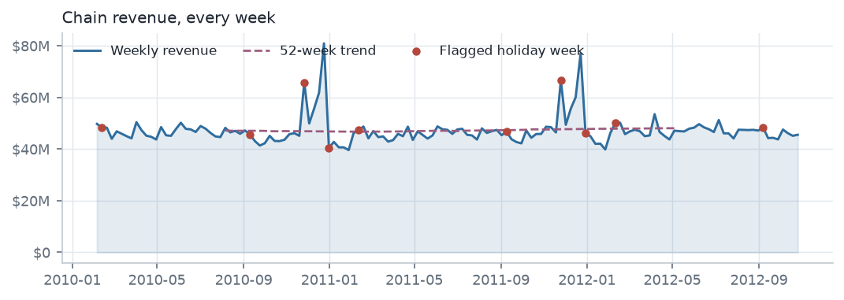
Figure 1. Chain revenue for every week in the window. The two spikes each year are Thanksgiving and the pre-Christmas week. The red markers are the weeks the dataset flags as holidays — note that they do not sit on the peaks.

2. The dataset and how it was built
Four source files were merged into one table, and every experiment runs against that single integrated dataset rather than the raw files.
- Integration. The sales file was joined to the store file on Store, then to the features file on Store and Date.
- Preprocessing. Dates parsed to timestamps, the holiday flag coerced to a boolean, markdown columns read as numbers, and rows without a sales figure dropped.
- Grain check. The Store-Department-Date key is unique: zero duplicates across all 421,570 rows.

Data quality
Check | Result | What it means
Rows / columns | 421,570 / 18
Duplicate Store-Dept-Date keys | 0 | the grain is clean
Rows with no missing value | 23.0% | markdowns are the whole story
Columns with any missing value | 5 | the five MarkDown columns
Markdown coverage | 35.9% | recorded only from 11 Nov 2011
Records with negative sales | 1,285 | net returns exceeded sales that week
Store x dept x week grid present | 80.9% | not every store sells every department

3. Exploratory data analysis
The profile below was computed from the raw merge rather than the integrated table. That distinction matters: the integrated file fills the MarkDown columns with zero, so profiling it would report no missing data at all.

Missing data
Only 23% of rows are complete, and the five MarkDown columns are the entire reason. They are absent for the first two years of the window and populated from November 2011 onward. Within that later window every single record carries a non-zero markdown, so the data contains no zero-markdown control group anywhere.
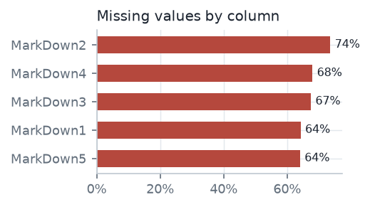
Figure 2. Missing values by column. No other column has a single gap.
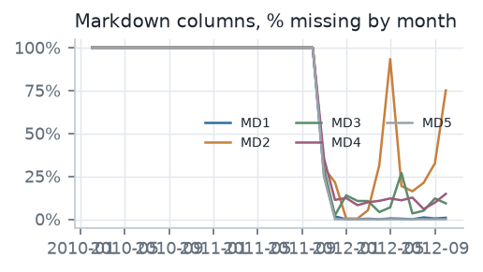
Figure 3. The same columns by month: the cliff at November 2011 is where markdown recording begins.

Distribution and shape
Weekly sales are strongly right-skewed with heavy tails: skewness 3.26 and excess kurtosis 21.5. 8.4% of records fall outside the Tukey fences, yet those records carry 40% of all revenue. They are not errors to be trimmed; they are the business.
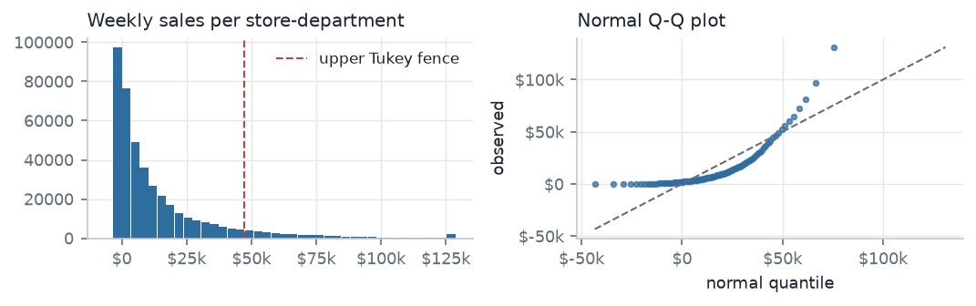
Figure 4. Left: the distribution of weekly sales per store-department, with the upper Tukey fence marked. Right: the normal Q-Q plot, which leaves the diagonal at both ends.
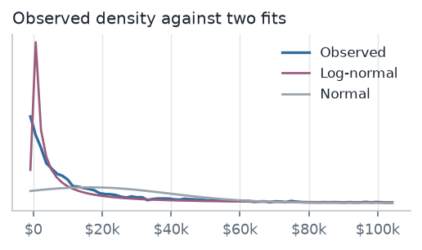
Figure 5. The observed density against a fitted normal and a fitted log-normal. The normal puts mass below zero and misses the peak.

Relationships
At the individual record level, correlations with sales are near zero because department-level noise dominates. Aggregating to store-week totals reveals the structural driver: floor space.
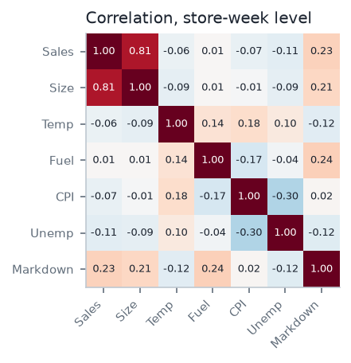
Figure 6. Correlation matrix at store-week level.

4. The eight experiments
# | Experiment | Method | Headline result
1 | Descriptive Statistics | Quartiles, IQR, Tukey fences, boxplots by store format | 8.4% of records are outliers but carry 39.6% of revenue
2 | Linear Regression | OLS on economic and structural drivers, three specifications | R² rises from 0.0017 (macro only) to 0.672 at store-week level
3 | Sampling | Simple random, stratified and systematic sampling vs population | A 10,000-record sample estimates the mean within 0.76%
4 | Clustering (K-Means) | Elbow + silhouette on six store features, PCA projection | Four store archetypes, silhouette 0.265
5 | Probability Distribution | Weekly sales as a random variable: PDF, CDF, exceedance | P(sales > $50k) = 0.076, carrying 37% of revenue
6 | Theoretical Distributions | Normal, log-normal, gamma and exponential fits with KS tests | Log-normal fits best (KS 0.097); Normal is rejected
7 | Statistical Inference | Welch t-test, ANOVA, Mann-Whitney, chi-square, correlations | Holiday lift of 7.1% is significant (p<0.001) but small (d=0.046)
8 | Time Series Analysis | Moving averages, multiplicative decomposition, 14-week forecast | Backtest MAPE 1.8% over 13 held-out weeks

Experiment 1 — Descriptive statistics
Quartiles and Tukey fences on every record. Q1 $2,080, median $7,612, Q3 $20,206, giving an interquartile range of $18,126 and an upper fence of $47,395. 35,521 records sit outside the fences.

Experiment 2 — Linear regression
Three specifications on the same target, fitted by ordinary least squares.
Specification | R² | Adjusted R² | RMSE
Economic drivers only (temperature, fuel, CPI, unemployment) | 0.00169 | 0.00168 | $22,692
Adding store size and the holiday flag | 0.06127 | 0.06125 | $22,004
Aggregated to store-week | 0.67185 | 0.67150 | $323,267

The jump from 0.06 to 0.67 comes almost entirely from floor space. What a store sells is set by what it is, not by the economy that week.

Experiment 3 — Sampling
Simple random samples at seven sizes, proportional stratified sampling by store format, and systematic sampling, each compared against the population mean of $15,981. A 10,000-record sample estimates that mean to within 0.76%. A thousand repeated samples of 500 records produce a distribution of sample means with an observed spread of $1,033 against the $1,016 that theory predicts, which is the central limit theorem holding on strongly skewed data.

Experiment 4 — Clustering
K-means on six standardised store features: weekly revenue, floor space, volatility, local CPI, local unemployment and holiday lift. Four archetypes were chosen from the elbow and from how readable the groups are.
Archetype | Stores | Avg week | Avg size | $/sq ft | Rev share
Flagship | 18 | $1.5M | 189,716 | $1,176 | 59.1%
Core performer | 11 | $987,149 | 120,758 | $1,189 | 23.1%
Steady mid-tier | 9 | $590,553 | 92,976 | $1,050 | 11.3%
Small format | 7 | $442,222 | 40,420 | $1,563 | 6.6%

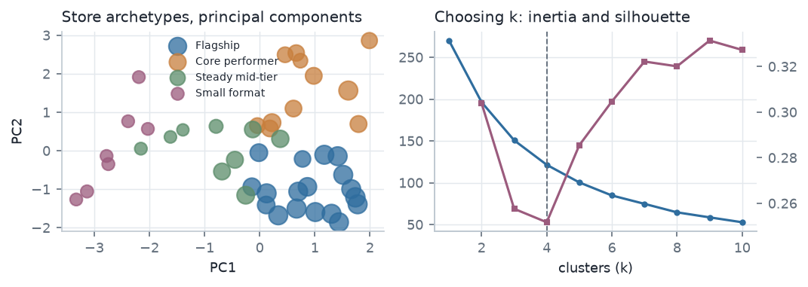
Figure 7. Left: the archetypes projected onto their first two principal components. Right: inertia and silhouette against k.
A caveat on k. The silhouette score at k=4 is 0.265, which is in fact a local minimum — higher values of k score better on that metric. Four was chosen because the inertia curve flattens there and because four groups are interpretable, not because the silhouette favoured it. The archetypes are a useful description, not a clean partition.

Experiments 5 and 6 — Distributions
Treated as a random variable, weekly sales have an expected value of $15,981 and a standard deviation of $22,711, a coefficient of variation above one. Four candidate distributions were fitted and compared by the Kolmogorov-Smirnov statistic.
Distribution | Fitted parameters | KS statistic | p-value
Gamma | a=0.5326, scale=30499.09 | 0.0238 | 0.0070
Log-normal | shape=2.0555, scale=4985.13 | 0.0975 | < 0.0001
Exponential | loc=0.08, scale=16242.45 | 0.1482 | < 0.0001
Normal | mu=16190.1, sigma=23123.7 | 0.2403 | < 0.0001

The normal distribution is rejected outright. Log-normal fits far better, and a log transform pulls skewness from 3.26 to -1.18 — overshooting slightly into mild left skew. Note that the chain-level weekly total is a different matter: aggregating 45 stores restores approximate normality, with a Shapiro-Wilk p of 0.0000.

Experiment 7 — Statistical inference
Test | Statistic | p-value | Reading
Welch t-test, holiday vs normal weeks | 7.001 | 0.0000 | significant; Cohen's d 0.046 is negligible
Mann-Whitney U (non-parametric check) | — | 0.4291 | agrees with the t-test
One-way ANOVA across store formats | 7,764 | 0.0000 | formats differ substantially
Kruskal-Wallis (non-parametric check) | — | 0.0000 | agrees with the ANOVA
Chi-square, markdown against holiday | 281.2 | 0.0000 | markdown activity is not independent of holidays

With 421,570 records almost any difference reaches significance, so effect size matters more than the p-value. The 95% confidence interval for mean weekly sales is $15,913 to $16,050.

Experiment 8 — Time series
Classical multiplicative decomposition with a 52-week period, then a forecast built by projecting the trend and multiplying by each target week's seasonal index.
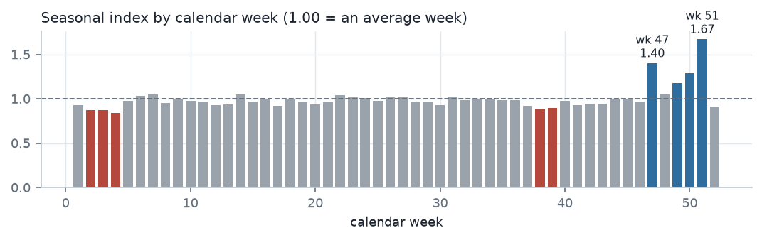
Figure 8. Seasonal index by calendar week. Week 51 runs 67% above trend and week 47 runs 40% above; between them they decide the quarter.
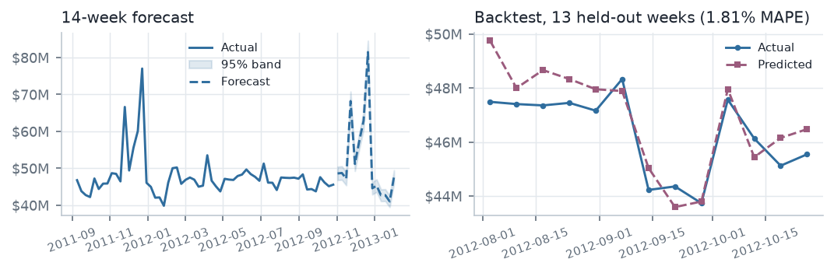
Figure 9. Left: fourteen weeks ahead with a 95% band. Right: the backtest against 13 fully held-out weeks.
The backtest is honest: both the trend and the seasonal index were refitted on the first 130 weeks only, so none of the 13 scored weeks influenced the model that scored them. It reaches 1.81% MAPE against 2.04% for a seasonal-naive benchmark — a win, but a narrow one, because a series this seasonal makes last year's same week a strong guess already. The held-out window is also a quiet stretch of late summer, so it does not test the peaks.

5. Business impact

Store format
Format | Stores | Avg size | Revenue | Share | $/sq ft
Type A | 22 | 177,248 | $4.33B | 64.3% | $1,111
Type B | 17 | 101,191 | $2.00B | 29.7% | $1,163
Type C | 6 | 40,542 | $405.5M | 6.0% | $1,667

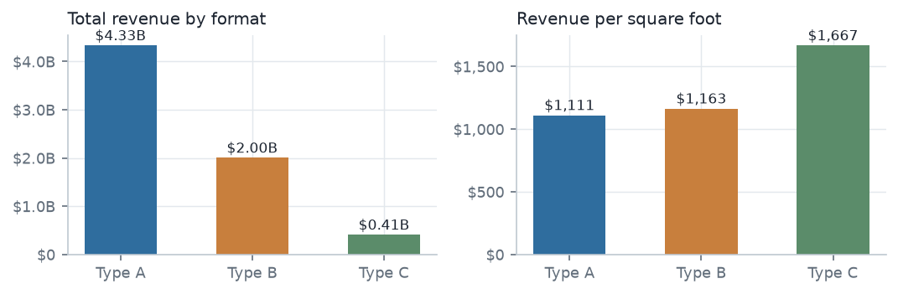
Figure 10. Type A takes most of the revenue because it has most of the square footage. Per square foot the ranking reverses.

The holiday calendar
Holiday | Weeks | Flagged week | Baseline | Lift
Thanksgiving | 2 | $66.2M | $46.8M | +41.6%
Labor Day | 3 | $46.9M | $43.8M | +7.1%
Super Bowl | 3 | $48.6M | $47.0M | +3.3%
Christmas | 2 | $43.2M | $61.3M | -29.5%

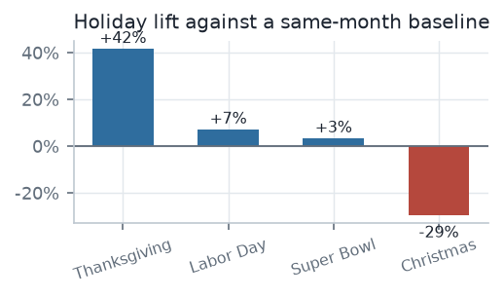
Figure 11. Only Thanksgiving earns its flag. The Christmas flag lands on the week after Christmas Day, which is a trough.

Departments
29 of 81 departments produce 80% of revenue. The top ten take 46%, while the bottom half of all departments contribute 8.7% between them.
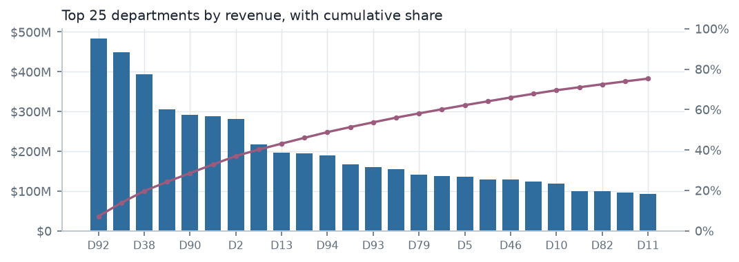
Figure 12. The 25 largest departments with cumulative share.
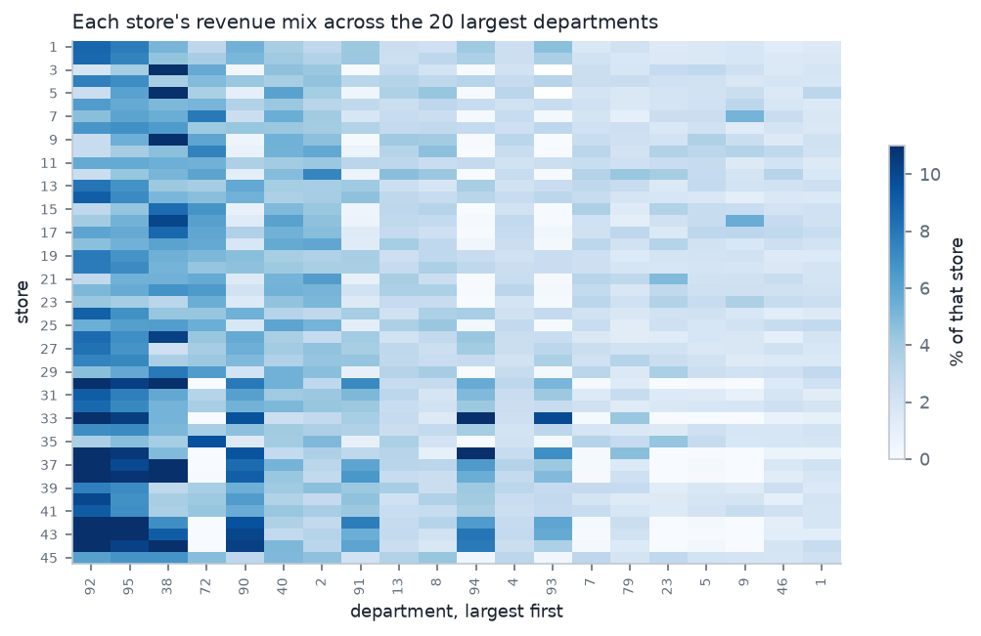
Figure 13. Each store's revenue mix across the 20 largest departments, as a share of that store's own revenue so large and small stores compare directly.

Markdowns
This is the finding most likely to be read the wrong way. Across records the deepest markdown quintile averages $19,903 against $9,477 in the lightest, which looks like a powerful promotion effect. It is mostly confounding: large departments receive large markdowns and already sell more. Removing each store-department's own average leaves a slope of $0.01 of sales per markdown dollar, explaining 0.1% of a store's own week-to-week swing.
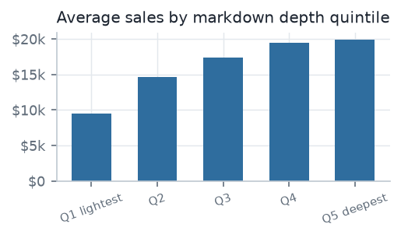
Figure 14. Average sales by markdown depth quintile. The spread is almost entirely store size.
Nothing in this dataset identifies a causal promotion effect. That needs a holdout group the data does not contain.

Productivity headroom
33 of 45 stores earn less per square foot than the top-quartile benchmark of $1,390. Lifting every one of them to that benchmark would add $1.69B, or 25% of revenue across the window, with no new floor space.
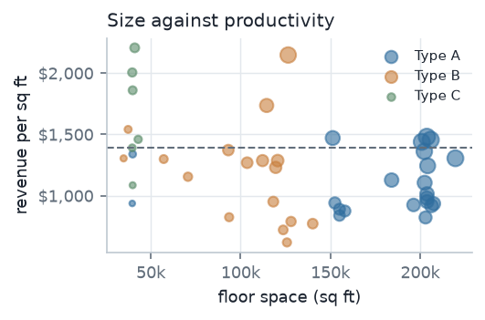
Figure 15. Floor space against revenue per square foot; bubble area is total revenue. If larger stores were more productive the cloud would slope up.

6. Limitations
- The markdown window. Markdowns are recorded for only 51 of 143 weeks, and every record in that window carries one. No with-versus-without comparison is possible on this data.
- The holiday flag. Used raw as a model feature it teaches the wrong calendar. Replace it with named holidays and a week-of-year index.
- The headroom figure is a ceiling. It assumes every store could reach the top-quartile benchmark. Catchment, local income and competition cap what any individual store can do.
- Significance is not importance. At this sample size nearly every test rejects its null hypothesis. Read effect sizes and confidence intervals.
- Clustering is descriptive. A silhouette of 0.265 means the archetypes overlap.
- Two and a half years, one chain. Only two complete Christmas peaks are available to learn seasonality from. Store identities are anonymous and carry no geography, so nothing here separates a regional effect from a store-specific one.

7. Reproducing this work
Everything is in the repository: https://github.com/jeet-1236/walmart-sales-intelligence
The dashboard reads pre-computed tables, so it runs without the 40 MB integrated dataset. To rebuild those tables from the raw Walmart files:
Script | Produces
build_dashboard_data.py | Runs all eight experiments and the business layer into one JSON of results
build_dashboard_sources.py | Flattens that JSON into 18 tidy CSVs, one per chart group
build_dashboard_extras.py | Adds the per-store weekly series, the store x department matrix, and growth and returns columns
build_eda.py | Profiles the raw merge into seven EDA tables
build_pages.py | Wraps the dashboard into the static site served by GitHub Pages
build_report_figures.py | Renders the figures in this document from those same tables
build_report_docx.py | Builds this document
app.py | A Streamlit version of the dashboard

A. Appendix: full column profile
Profiled from the raw merge of all four source files. Blank cells are columns where the statistic does not apply.
Column | Role | Missing | Unique | Mean | Median | Std | Skew | Kurt. | Outliers | Neg.
Store | key | 0.0% | 45
Dept | key | 0.0% | 81
Date | key | 0.0% | 143
Weekly_Sales | target | 0.0% | 359,464 | 15,981.3 | 7,612.0 | 22,711.2 | 3.26 | 21.5 | 8.4% | 1,285
IsHoliday | flag | 0.0% | 2
Type | attribute | 0.0% | 3
Size | attribute | 0.0% | 40 | 136,727.9 | 140,167.0 | 60,980.6 | -0.33 | -1.2 | 0.0% | 0
Temperature | driver | 0.0% | 3,528 | 60.1 | 62.1 | 18.4 | -0.32 | -0.6 | 0.0% | 69
Fuel_Price | driver | 0.0% | 892 | 3.4 | 3.5 | 0.5 | -0.10 | -1.2 | 0.0% | 0
CPI | driver | 0.0% | 2,145 | 171.2 | 182.3 | 39.2 | 0.09 | -1.8 | 0.0% | 0
Unemployment | driver | 0.0% | 349 | 8.0 | 7.9 | 1.9 | 1.18 | 2.7 | 7.6% | 0
MarkDown1 | promotion | 64.3% | 2,277 | 7,246.4 | 5,347.4 | 8,291.2 | 3.34 | 17.6 | 6.4% | 0
MarkDown2 | promotion | 73.6% | 1,499 | 3,334.6 | 192.0 | 9,475.4 | 5.44 | 37.6 | 15.8% | 1,311
MarkDown3 | promotion | 67.5% | 1,662 | 1,439.4 | 24.6 | 9,623.1 | 8.40 | 77.7 | 13.6% | 257
MarkDown4 | promotion | 68.0% | 1,944 | 3,383.2 | 1,481.3 | 6,292.4 | 4.85 | 30.0 | 9.6% | 0
MarkDown5 | promotion | 64.1% | 2,293 | 4,629.0 | 3,359.4 | 5,962.9 | 8.17 | 107.8 | 5.1% | 0

Dashboard: https://jeet-1236.github.io/walmart-sales-intelligence/ Repository: https://github.com/jeet-1236/walmart-sales-intelligence

